**Functional Design (FD)**

**Project Integration**

**Enschede, 26 March 2019**

**Version 1.0**

**Made by: Group: 10**

Hong Trinh 438443

Phuc Le 456061

Shyam Shiwakoti 426021

Thanh Nguyen 444856

Minh Le 467475

Van Nguyen 444878

**Content**

**Introduction**4

**Analysis of requirements**5

**2.1 Requirement for the mobile device**6

**2.2 Requirement for the Alexa Echo Dot 2nd:**6

**Concept principles**8

**3.1 Description of alternative concepts**8

**3.2 Comparison of concept principles**8

**Methodological overview**8

**Weighted criteria for concepts**11

**Processing Platform**11

**Healthcare Functionality**12

**Voice Assistant**13

**Battery**14

**Storage method**15

**Wristband case material**16

**Display monitor**17

**Notification**18

**3.3 Choice of the most promising concept principle**19

**Elaboration of concept design**21

**4.1 Overview of concept design**21

**4.2 Elaboration of concept design**22

**4.2.1 Mechanical**22

**4.2.2 Electrical**23

**4.2.3 Electronic**24

**4.2.4 Software**26

**4.3 Functional design integration**27

**Appendix**29

**Figure 1: Alternative concept principles**29

**Abbreviations**

|  |  |
| --- | --- |
| **Abbreviation** | **Description** |
| CD | Concept Design |
| FR | Functional Requirement |
| SR | System Requirement |
| CP | Concept Principle |
| MTBF | (**mean** time between failures) **is** a measure of how reliable a hardware product or component **is**. For most components, the measure **is** typically in thousands or even tens of thousands of hours between failures. |
| MTTR | Mean time to repair (MTTR) is a basic measure of the maintainability of repairable items. It represents the average time required to repair a failed component or device. |

# Introduction

This aim of this document is to determine the FR based on the SR and describe the steps making the CD. The main functions SR document is analysed and splited into sub-function in this phase. The detail of each function will be showed in CD phase. The structure of document includes:

* The main requirements of SR is analysed.
* Generating the possible CPs for main functions.
* Comparison, evaluation and selection between alternative CPs.
* Generation the CD by expressing the sketches, block diagram, electronical, hardware and software.
* A choice of the most promising CP is made..
* The overview of CD.

# Analysis of requirements

The analyze of the functional and technical requirements create key-parameters for product. Nevertheless, the product is divided in two separate system (mobile device and Alexa Echo Dot 2nd).

The mobile device have different functional and technical requirement than the Alexa Echo Dot 2nd. The analysis of the requirement for the mobile and stationary device is slit up on different section, moreover the whole product requirements is on the following table.

|  |  |
| --- | --- |
| **Functional requirements** | **Technical requirements** |
| * Registration of devices * Display data in a graphical representation on GUI * Capability to store data | * Total budget of 100 euro * Total project labor is around 200 hours * CE standard * Medical standard (IEC 60601-1) * Wireless communication * Implementing standard IDE * Catching error for error handling * Software application (GUI) * Database * MTBF Reliability * MTTR Maintainability |

By analyzing the functional requirement for registration of device and technical requirement for wireless communication brings that the whole system need to use a programming language for Wi-Fi communication.

The combination with software application with implementing standard IDE and catching error for error handling requirements and display data in a graphical representation brings that the GUI need to be created by an objective oriented standard programming language (OO programming language).

The functional requirement for storing data and the technical requirement for database create a parameters of having a programming language and a processor for this.

The wireless communication, database and MTBF reliability requirements brings the conclusion of having a processor for Wi-fi communication. The mobile device need a processor platform which can handle Wi-Fi communication.

The CE standard, medical standard, MTBF Reliability and MTTR Maintainability create a parameter for the material of the housing of the mobile device.

By analyzing the total budget and the total labor requirement brings that every component which need to be used to make the prototype need to be economical and a component that required that the group work less than 200 hours.

## 2.1 Requirement for the mobile device

All requirement of the mobile device based on the system requirement document are describe on the table below:

|  |  |
| --- | --- |
| **Functional requirements** | **Technical requirements** |
| * Turn on/off possibility * Measure human heartbeat rate * Display user data in a numerical representation * Capability to send data via a wireless connection * Capability to work 24/7h | * Physical size less than 6.5 x 2 x 0.2cm * Adjustable device to the user * Power consumption equal or less than 6.6 Watt * Standard power connectors |

By analyzing the functional requirement of having turn on/ off possibility, measure human heart beat rate and display user data in a numerical representation brings the mobile device need to have a power switch, a heartbeat sensor and a screen.

By analyzing the physical size requirements and that it need to be an adjustable device to the user brings that the mobile device need to have an adjustability case.

By analyze that the power consumption of the mobile device and that it need to have a processor which is for the performance of all the functionality of the device means it need a low power processor platform.

The technical requirement of the power consumption, standard power connectors and adjustable device to the user brings that the mobile device power source should be a chargeable battery source.

## 2.2 Requirement for the Alexa Echo Dot 2nd:

All requirement of the Alexa Echo Dot 2nd based on the datasheet and manufacturer document are describe on the table below:

|  |  |
| --- | --- |
| **Functional requirements** | **Technical requirements** |
| * Turn on/off possibility * Capability to send & receive data via wireless connection (wifi, bluetooth) * Capability to work 24/7h * Portable device * Voice control * Built-in speaker | * Physical size more than 6.5 x 3 x 5 cm * Mass 163 gram * Power consumption equal or less than 400 Watt * Standard power connectors * AC power adaptor, USB charging cable |

By analyze that Echo Dot is a hands-free, voice-controlled device that uses the same far-field voice recognition as Amazon Echo Dot has a small built-in speaker. This time we just focus on the main function that using voice control on Alexa Echo Dot 2nd.

# Concept principles

## 3.1 Description of alternative concepts

This chapter is going to introduce about generated concepts which was generated during the brainstorm phase by all team members, then it is going to be evaluated due to the technical and functional requirements of the project to guarantee that everything should be met the orders of the project and as well as customer’s.

## 3.2 Comparison of concept principles

Firstly, the methodological overview table is made to represent the generated concepts base on each functional categories

## Methodological overview

|  |  |  |  |
| --- | --- | --- | --- |
| Categories\Options | Concept 1 | Concept 2 | Concept 3 |
| Processing platform | Image result for MCU (MicroController Unit)  MCU (MicroController Unit) | Image result for CPU (Central Processing Unit)  CPU (Central Processing Unit) | Image result for MPU (Micro Processing Unit)  MPU (Micro Processing Unit) |
| Healthcare functionality | Image result for medicine reminder  Medicine reminder | Notification | Related image  Heartbeat measurement |
| Voice Assistant | Image result for apple homepod  Apple HomePod | Image result for alexa echo dot 2  Alexa Echo Dot 2 | Image result for google home  Google Home |
| Battery | Li-Ion | Image result for pin đồng hồ  Lithium | NiMH |
| Storage method | Image result for sd card  SD card | Image result for cloud storage  Cloud |  |
| Wristband case material | Image result for wood watch case  Wood | Image result for plastic watch case  plastic | Image result for Stainless steel watch case  Stainless steel |
| Display Monitor | Image result for oled ssd1306  OLED | Image result for oled ssd1306  LCD | Image result for tft display  TFT |
| Notification | Buzzer | Image result for human voice  Human voice | Music |

Due to the requirements of the project which will have a product, therefore the selection must be made to seek out which is the most outstanding CP. To do that, the morphologic overview is generated which bases on some typical categories for evaluating.

Next, the tables below demonstrate the possibility and the priority or the 3 CPs that were generated during brainstorm phase. Each category will have 100% point. The choice will be made by the agreement of all teammate with a plus simple.

## 

## Weighted criteria for concepts

### Processing Platform

|  |  |  |  |
| --- | --- | --- | --- |
| Criteria\Options | MCU (MicroController Unit) | CPU (Central Processing Unit) | MPU (Micro Processing Unit) |
| Power consumption (10%) | + |  | + |
| Performance (10%) |  | + |  |
| Cost (10%) | + |  | + |
| Size (25%) | + | + | + |
| Speed (15%) | + | + |  |
| Interfaces (connect different elements of the product) (30%) | + | + | + |
| Total | 90% | 70% | 75% |

Microcontroller is a small computing device on a single chip. They are used especially in applications where only specific repetitive tasks need to be performed. The microcontroller does not require an additional memory device, therefore it becomes a cheaper solution.

For general speed considerations, the MCU usually wins due to its ability to address the most time critical applications because of the processor core used in them. Asides from the low power modes, the actual amount of power consumed by an MCU is a whole lot lower than what a microprocessor consumes, because the larger the processing capability, the more the amount of power required to keep the processor up and running.

Microcontrollers therefore tend to find applications where ultra-low power processing units are required such as remote controls, consumer electronics and several smart devices where the design emphasis is on the longevity of battery life. They are also used where a highly deterministic behaviour is needed.

Microcontrollers are mostly used in solutions with a very tight BOM budget and with stringent power requirements

### Healthcare Functionality

|  |  |  |  |
| --- | --- | --- | --- |
| Criteria\Options | Medicine reminder | Notification | Heartbeat measurement |
| Effectively (40%) | + | + | + |
| Complexility (30%) |  |  | + |
| Time Response (30%) |  |  | + |
| Total | 40% | 40% | 100% |

Heartbeat measurement is the best outstanding idea about the healthcare functionality. Due to its application in society, the demand of the healthcare medical, especially for the elders, heartbeat controlling is a critical thing that should be cared about. Furthermore, the complexity of it in this project is not that hard comparing with the implementation of the other 2 ideas. Last but not least, user can see the live heartbeat and mostly the responding is fast enough to see a live heartbeat measuring.

### Voice Assistant

|  |  |  |  |
| --- | --- | --- | --- |
| Criteria\Options | Apple HomePod | Alexa Echo Dot 2 | Google Home |
| Communication (25%) | + | + | + |
| Application (20%) | + | + | + |
| Cost (15%) |  | + |  |
| Implementation  (40%) |  | + | + |
| Total | 45% | 100% | 85% |

Provided by Amazon, Alexa Echo Dot is a smart home assistant device which mostly uses English voice to communicate and response to user. With a cheaper price than other 2 voice assistant devices, it is also easy to implementation with a lot of MCU and have a lot of available supported libraries to implement and use.

### Battery

|  |  |  |  |
| --- | --- | --- | --- |
| Criteria\Options | Li-Ion | Lithium | NiMH |
| Cost efficient (15%) | + | + |  |
| Size (20%) |  | + |  |
| Weigh (20%) |  | + |  |
| Cell voltage (15%) | + | + |  |
| Safety (20%) |  | + | + |
| Max Temperature (10%) | + | + | + |
| Total | 40% | 100% | 30% |

All member in the team agree with the Lithium battery type as it first reason is the small size which is the most important element to choose it : small, flat, thinner, and lighter than other type of batteries. With replaceable battery type, lithium can be chosen for a small device such a measuring heartbeat.

### Storage method

|  |  |  |
| --- | --- | --- |
| Criteria\Options | SD Card | Cloud |
| Capacity (30%) | + | + |
| Up/download speed |  | + |
| Safety (15%) | + | + |
| Implementation (10%) |  | + |
| Networking requirement (10%) |  | + |
| Reliability & Performance (15%) | + | + |
| Total | 60% | 100% |

Cloud - might be considered as the most convenient idea so far for the storing data of device. By using internet, the output data can be easy upload and download very fast and safe without afraid of breaking SD card or forgot SD card at home when go out. Data can be accessed online everywhere, everytime.

### Wristband case material

|  |  |  |  |
| --- | --- | --- | --- |
| Criteria\Options | Wood | Plastic | Stainless steel |
| Weight (40%) |  | + |  |
| Ability to manufacture (20%) | + | + |  |
| Mechanical properties (20%) |  | + |  |
| Physic properties (10%) |  | + | + |
| Chemical properties (10%) |  | + | + |
| Total | 20% | 100% | 20% |

Plastics are susceptible to brittle crack growth fractures as a result of cyclic stresses. Plastics are also prone to thermal softening if the cyclic stressor rate is high. Plastics can be made conductive for special applications

1. Mechanical Properties: e.g. stiffness, strength, ductility, hardness, toughness, etc.
2. Physical Properties: e.g. density, electrical conductivity, thermal conductivity, etc.
3. Chemical Properties: e.g. corrosion resistance in various environments.
4. Manufacturing Properties: e.g. formability, machinability, ease of joining, etc.

Economics: Cost of the material as well as cost of processing the material into required shape. As part of overall economics, both availability and recycling aspect should also be taken into account.

### Display monitor

|  |  |  |  |
| --- | --- | --- | --- |
| Criteria\Options | OLED | LCD | TFT |
| Size (25%) | + | + |  |
| Power usage (10%) | + | + | + |
| Thinness (20%) | + | + |  |
| Brightness (20%) | + |  |  |
| View angle (5%) | + | + | + |
| Implementation (20%) | + | + | + |
| Total | 100% | 80% | 35% |

The technology ofOLED displays offers high brightness, low power consumption and in an ultra-thin package. The advantage of OLED displays is that these displays can be built on a very thin substrate, allowing the display to be thinner and flexible. OLEDs are brighter than LEDs because they do not require glass, which absorbs some of the light. LEDs and LCDs both require glass for support.

OLEDs do not require backlighting like other color LCD panel displays. LCDs operate by blocking areas of the backlight to make the images that you see. OLEDs generate their own light which not only eliminates the need for a backlight, but consumes less power than the backlight required on a Liquid Crystal Display.

Very wide viewing angle: OLEDs produce their own light which provides a large field of view, an estimated 170 degrees. Because LCDs operate by blocking light, they have an intrinsic viewing obstacle from certain angles.

### Notification

|  |  |  |  |
| --- | --- | --- | --- |
| Criteria\Options | Buzzer | Human voice | Music |
| Attractive (30%) | + | + | + |
| Complexity (20%) | + |  |  |
| Addition device (15%) | + | + | + |
| Implementation (35%) | + |  | + |
| Total | 100% | 45% | 80% |

To notice user about the measurement, a buzzer can be used as a small speaker for beeping as notifications from device. It work the same principle as an alarm. Not too hard to implement with the device, music could be also included in the buzzer by adding music tones to make songs to attract user’s attentions.

## 3.3 Choice of the most promising concept principle

|  |  |  |  |
| --- | --- | --- | --- |
| Categories\Options | Concept 1 | Concept 2 | Concept 3 |
| Processing platform | Image result for MCU (MicroController Unit)  MCU (MicroController Unit) | Image result for CPU (Central Processing Unit)  CPU (Central Processing Unit) | Image result for MPU (Micro Processing Unit)  MPU (Micro Processing Unit) |
| Healthcare functionality | Image result for medicine reminder  Medicine reminder | Protect from harmful | Related image  Heartbeat measurement |
| Voice Assistant | Image result for apple homepod  Apple HomePod | Image result for alexa echo dot 2  Alexa Echo Dot 2 | Image result for google home  Google Home |
| Battery | Li-Ion | Image result for pin đồng hồ  Li-Thium | NiMH |
| Storage method | Image result for sd card  SD card | Image result for cloud storage  Cloud |  |
| Wristband case material | Image result for wood watch case  Wood | Image result for Stainless steel watch case  Stainless steel | Image result for plastic watch case  Plastic |
| Display Monitor | Image result for oled ssd1306  OLED | Image result for oled ssd1306  LCD | Image result for tft display  TFT |
| Notification | Buzzer | Image result for human voice  Human voice | Music |

Summary, the final device is a mobility device which measuring heartbeat. The mobility device is decided creating a wristband with plastic case. The result of measurement will be displayed on the oled screen. LiThium battery is used to supply power for device. Echo Dot communicate with MCU to send command to device. Furthermore, the measured data is stored in the cloud.

# Elaboration of concept design

## 4.1 Overview of concept design

The diagram below shows the performs of medical devices and how it been triggered using Alexa to transmit the information.

As soon as the nurse makes commands for Alexa , Alexa will receives orders then send a message to the watch . Function of the watch will be triggered if it received a correct orders from the nurse or else if the nurse made a wrong commands , Alexa still receives orders but the information will not be delivered to the Watch, hence the nurse have to repeat her/his orders again.

After being triggered, signals will be transmitted to the sensor then heartbeats of the patience will be measured at the meantime. Following this, the heartbeats value are shown on the display which is attached to the wrist band. All datas are subsequently saved in the Memory storage. Eventually, heartbeats information are gathered and sent to the nurse’s devices (computer, smartphone, ect…).

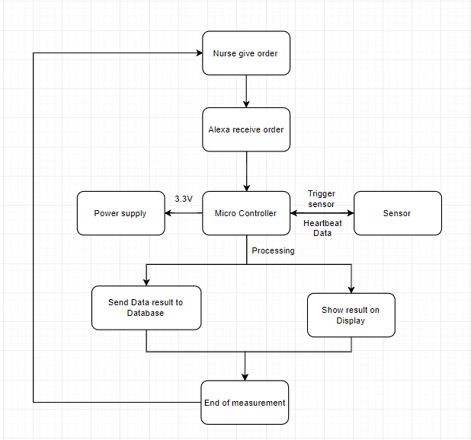

For the safety, the system have some following case in order to make it work without any trouble for the user:

-The system’s safety is measured base on EMC rules and the components are built base on their datasheet.

-There is an emergency alarm in the wristband, which will buzzed when there is something wrong with the user.

-The fuse will be added at the beginning of the system in order to keep safe for the system when trouble appears

## 4.2 Elaboration of concept design

### 4.2.1 Mechanical

The wristband design overview

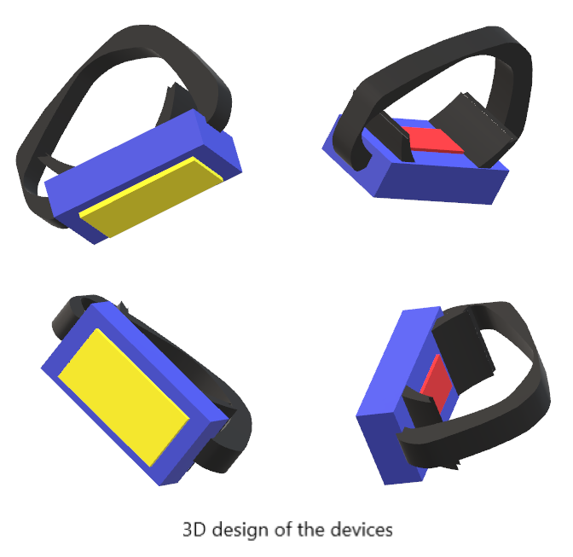

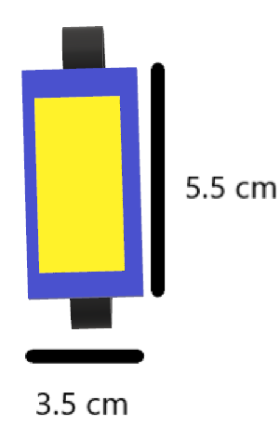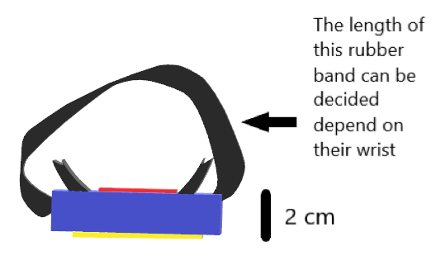

This is the model design of the devices that we concern about, with all the components will be place in the purple part ( the container) with the thickness around 2 mm, the upper part ( the yellow part) is where the monitor should be placed and the bottom part (the red part) is the sensor which should be placed as near as skin surfaces so it can precisely detect the heart beats of patience. Following this , the black part which is attached beneath the purple part and close two sides of the sensor , it was designed in other to keep the devices stable on the wrist.

The Alexa overview

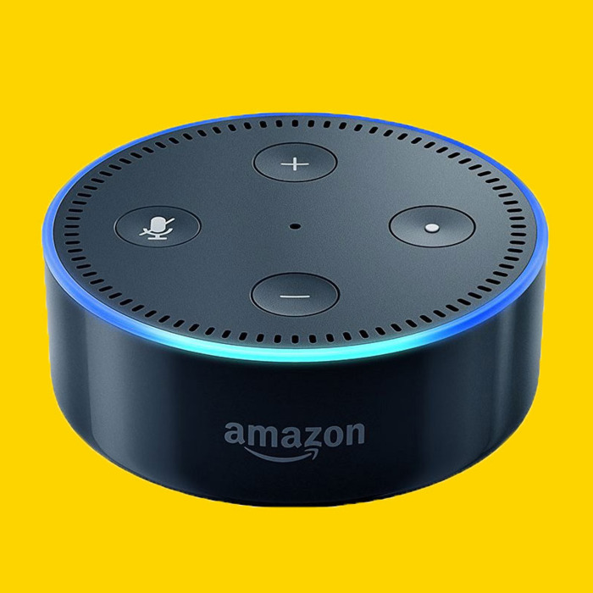

### 4.2.2 Electrical

Alexa can be connected directly to 220 AC power supply since Alexa is regularly held at one place (usually places close to patiences). So this part we will focus on the mobile device.

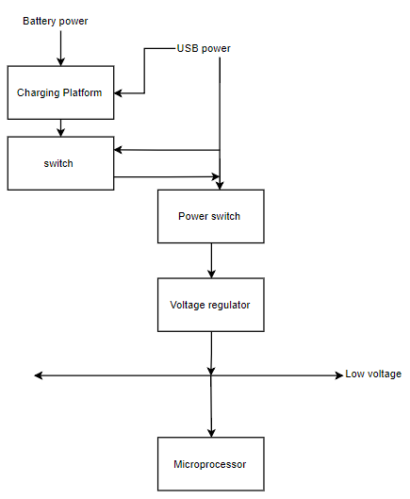

*Figure :Electrical Concept of the mobile device*

|  |  |  |  |  |
| --- | --- | --- | --- | --- |
| Input | | | | |
| Name | Description | Relation | Value | Unit |
| Low voltage | Voltage USB port |  | 5 | Volt |

|  |  |  |  |  |
| --- | --- | --- | --- | --- |
| Output | | | | |
| Name | Description | Relation | Value | Unit |
| Low Voltage | Voltage from Converter |  | 3.3 | Volt |

### 4.2.3 Electronic

The electronic component of this project mainly consist of sensors and the processing unit. Heartbeat sensor and Microcontroller can be used due to it flexibility and functionality.

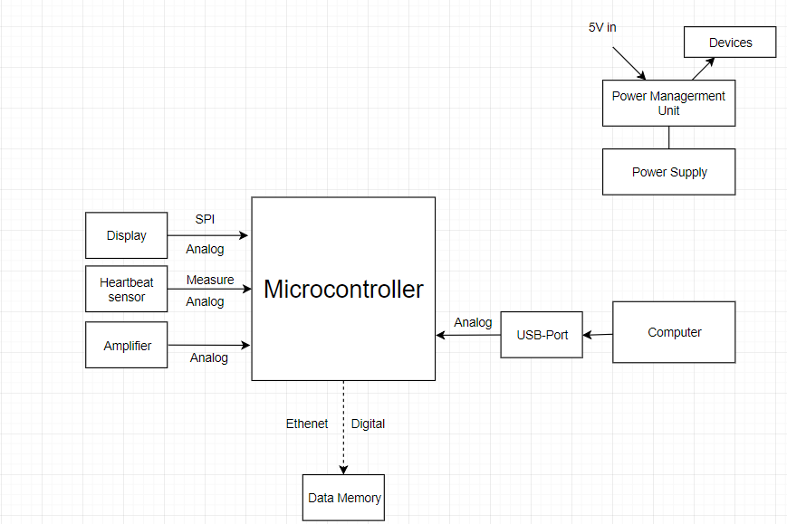

### 4.2.4 Software

Picture: Block Diagram of function of software

4.2.4.1 Language

The Graphical User Interface will be programmed with C# programming language because C# is easy to understand and code for our team members.

The controller on the device will be programmed with Micropython because of the previous experience of team members with micro python.

Database will be programmed with MySql as it is well known programming language for group.

4.2.4.2 Environment

The C# code will be programmed in Microsoft Visual Studio integrated development environment (IDE) by Microsoft. Group decided this IDE because of its nice integration, easy to use and its Plugins provided by it.

The Micropython will be programmed in uPcraft and Thonny because it is reliable, faster and easy to use.

## 4.3 Functional design integration

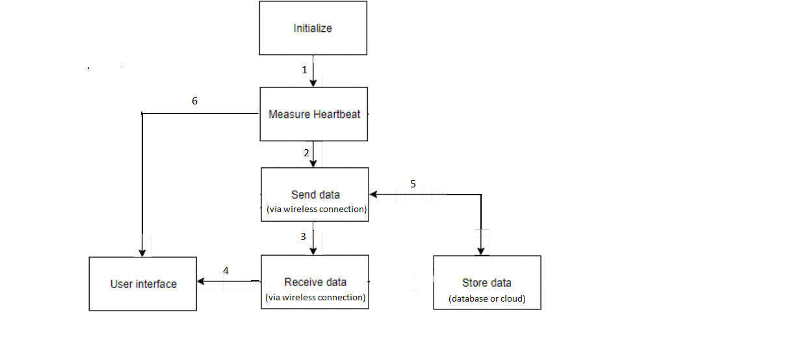

**Function 1: Initialize**

|  |  |  |  |  |
| --- | --- | --- | --- | --- |
| **Number** | **Requirement** | **Relation** | **Value** | **Unit** |
| 1 | Registration | = | true | -- |
| 2 | Turn on/off possibility | = | true | -- |

**Function 2: Measure heartbeat**

|  |  |  |  |  |
| --- | --- | --- | --- | --- |
| **Number** | **Requirement** | **Relation** | **Value** | **Unit** |
| 1 | Measure human heart rate | = | true | -- |

**Function 3: User Interface**

|  |  |  |  |  |
| --- | --- | --- | --- | --- |
| **Number** | **Requirement** | **Relation** | **Value** | **Unit** |
| 1 | Display Patience information | = | true | min |
| 2 | Show patience graph information | = | true | day |

**Function 4: Send Data**

|  |  |  |  |  |
| --- | --- | --- | --- | --- |
| **Number** | **Requirement** | **Relation** | **Value** | **Unit** |
| 1 | Capability to send data via a wireless connection | = | true | -- |

**Function 5: Store Data**

|  |  |  |  |  |
| --- | --- | --- | --- | --- |
| **Number** | **Requirement** | **Relation** | **Value** | **Unit** |
| 1 | An entity that receive data and store it. | = | true | -- |
| 2 | An entity that can store data and send data | = | true | -- |

**Function 6: Receive Data**

|  |  |  |  |  |
| --- | --- | --- | --- | --- |
| **Number** | **Requirement** | **Relation** | **Value** | **Unit** |
| 1 | Capability to receive data via a wireless connection | = | true | -- |

## 

# Appendix

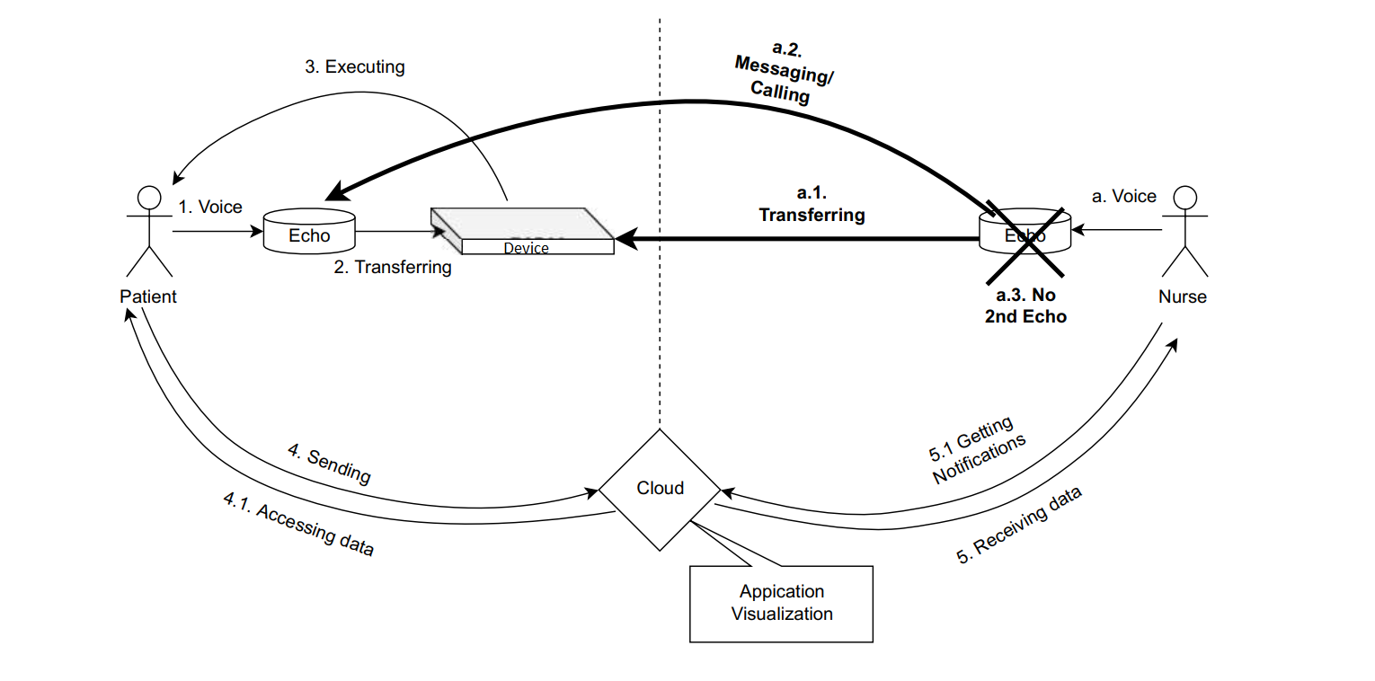

### Figure 1: Alternative concept principles